https://leetcode.com/problems/partition-labels/description/

Find the last appearance of a character.'

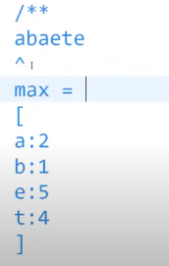

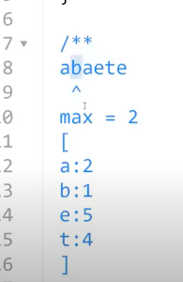

max position of a is 2; for b-> it is 1; but for this case a's max is 2.